# Physics 30 Lesson 1 to 4 Review

1. An empty sled is sliding on frictionless ice when Susan drops vertically from a tree above onto the sled.

a. When she lands, does the sled speed up, slow down, or keep the same speed? Explain.

b. Later, Susan falls sideways off the sled. When she drops off, does the sled speed up, slow down, or keep the same speed? Explain.

1. Why can a batter hit a pitched baseball further than a ball tossed in the air by the batter?
2. A 12 kg hammer strikes a nail at a velocity of 8.5 m/s and comes to rest in a time interval of 8.0 ms.

a. What is the impulse imparted to the nail? (102 kg⋅m/s)

b. What is the average force acting on the nail? (12750 N)

1. A hockey player makes a slap shot, exerting a force of 30 N on the hockey puck for 0.16 s seconds.

a. What impulse is given to the puck? (4.8 N·s)

b. If the hockey puck has a mass of 0.115 kg and was at rest before the shot, what speed does it head towards the net? (42 m/s)

1. A constant friction force of 25 N acts on a 65 kg skier for 20 s. What is the skier’s change in velocity? (–7.69 m/s)
2. For a top tennis player, a tennis ball may leave the racket on the serve with a speed of 55 m/s. If the ball has a mass of 0.060 kg and is in contact with the racket for about 4.0 ms, estimate the average force of the ball. Would this force be large enough to lift a 60 kg person? (825N, enough)
3. Water leaves a hose at a rate of 1.5 kg/s with a speed of 20 m/s and is aimed at the side of a car, which stops it. (That is, we ignore any splashing back). What is the force exerted by the water on the car? (–30N)
4. Is it possible for an object to receive a larger impulse from a small force than from a large force? Explain.
5. An object travelling east at 40 m/s and having a mass of 50 kg collides with an object with a mass of 40 kg and travelling east at 20 m/s. If they stick together on contact:

a. What is the resultant velocity of the combined mass? (31.1 m/s east)

b. What is the kinetic energy of the combined mass ? (43.5 kJ)

1. A 68 kg object travelling west at 45,750 m/s collides with a 56,975 kg object travelling east at 0.0078 m/s. If the 68 kg object ends up travelling east at 22,456 m/s what is the velocity of the 56,975 kg object? (81 m/s west)
2. A 95 kg halfback moving at 4.1 m/s on an apparent breakaway for a touchdown is tackled from behind. When he was tackled by an 85 kg cornerback running at 5.5 m/s in the same direction, what is their mutual speed immediately after the tackle? (4.76 m/s)
3. Calculate the recoil velocity of a 5.0 kg rifle that shoots a 0.020 kg bullet at a speed of 620 m/s? (–2.5 m/s)
4. A 10000 kg railroad car, A, travelling at a speed of 24.0 m/s strikes an identical car, B, at rest.

a. If the cars lock together as a result of the collision, what is their common speed just after the collision? (12.0 m/s)

b. Is the collision elastic or inelastic? If the collision is inelastic, calculate how much of the initial kinetic energy is transformed to thermal or other forms of energy. (1.44 × 106 J)

1. Billiard ball A of mass 0.400 kg moving with speed 1.80 m/s strikes ball B, initially at rest of mass 0.500 kg. As a result of the collision, ball A is deflected at an angle of 30.0˚ with a speed of 1.10 m/s. Find the resultant velocity of ball B. (0.808 m/s at 33˚ from original direction of motion)
2. A mass of 50 kg travelling north at 45 m/s collides with a mass of 60 kg travelling 50 m/s at 28˚ N of W. If they stick together on contact, what is the resulting velocity of the combined masses? (41.1 m/s at 36˚ W of N)
3. A 100 kg mass explodes into three parts. The first part travels away at 50 m/s straight north and has a mass of 20 kg. The second part travels away at 35 m/s straight west and has a mass of 50 kg. What is the resultant velocity of the third part? (66.7 m/s @ 30o S of E)
4. The following data relates the mass and change in velocity for various objects having the same impulse over a 3.0 second time interval. Find the average force exerted on the objects during the impulse.

|  |  |
| --- | --- |
| Mass (kg) | (m/s) |
| 37.5  50.0  62.5  75.3  93.8  125 | 20  15  12  10  8.0  6.0 |

**Old diploma exam questions**

*Use the following information to answer the next question.*

At a coal mine, a train engine bumps an empty hopper car that has a mass of 1.00 × 104 kg such that it rolls at a constant speed of 2.00 m/s under a coal storage bin. When the hopper car triggers an electromagnetic switch on the track below the storage bin, the bin drops a load of 1.20 × 104 kg of coal into the hopper car.

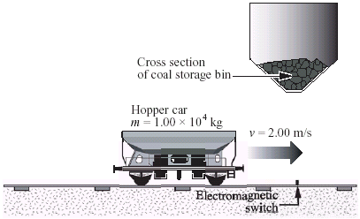**Numerical Response**

Numerical Response

1. The speed of the hopper car immediately after receiving the load of coal, expressed in scientific notation, is _____× 10*-w* m/s.

(Record your **three-digit answer** in the numerical-response section on the answer sheet.)

1. Which of the following quantities are scalar quantities?

A. Acceleration and impulse

B. Acceleration and mass

C. Impulse and energy

D. Energy and mass

*Use the following information to answer the next two questions.*

When a motor vehicle slows down suddenly and the wheels are locked, the kinetic energy of the vehicle is transferred into heat energy. A skid mark is left on the road. Police can estimate the speed at which a vehicle was travelling before the brakes were applied b measuring the length of a skid mark *d* and applying the formula *,* where  = 0.750for a dry road surface.

After the brakes are applied and the wheels are locked, a 1.00 × 103 kg vehicle comes to a stop in 3.80 s. The vehicle leaves a 52.9 mskid mark.

Numerical Response

1. The estimated speed of the vehicle is calculated to be __________ m/s.

(Record your **three-digit answer** in the numerical-response section on the answer sheet.)

*Use your recorded answer from* ***Numerical Response 2*** *to answer* ***Numerical Response 3****.*

Numerical Response

1. The magnitude of the impulse necessary to stop the vehicle, expressed in scientific notation, is ____× 10w kg·m/s.

(Record your **three-digit answer** in the numerical-response section on the answer sheet.)

1. A car is travelling north at 60 km/h. It crashes into a truck, which is stationary. After the collision, the two vehicles lock together and travel off in the car's original direction. Which of the following statements about the collision is true?

A. Both momentum and kinetic energy are conserved.

B. Neither momentum nor kinetic energy is conserved.

C. Momentum is conserved, but kinetic energy is not conserved.

D. Kinetic energy is conserved, but momentum is not conserved.

1. The energy stored in a spring is given by Ep = ½ kx2. Which of the following graphs shows the relationship between the energy stored in a spring, Ep, and the distance, x, that the spring is stretched?

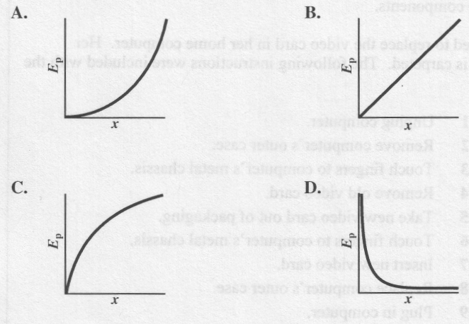

*Use the following information to answer the next question*.

**Force on a Ball as a Function of Time**

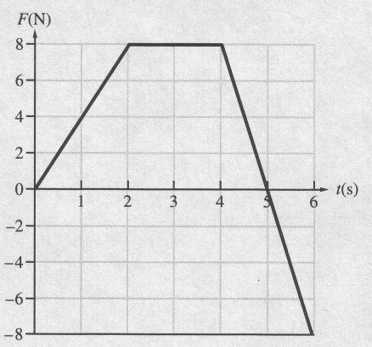

1. The net impulse delivered to the ball from t = 0.0 s to t = 6.0 s is

A. 24 N·s

B. 28 N·s

C. 32 N·s

D. 48 N·s

*Use the following information to answer the next question*.

A coal chute angled at 30° to the horizontal releases 1.50 × 104 kg of coal to fill a stationary, empty 5.0 × 103 kg cart. The cart and coal move forward with a horizontal velocity of 2.0 m/s.

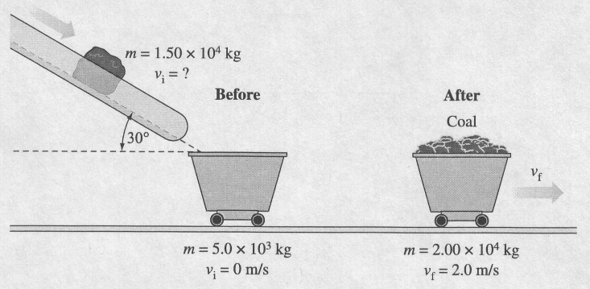

1. The speed of the coal along the chute is

A. 1.5 m/s

B. 2.7 m/s

C. 3.1 m/s

D. 5.3 m/s

______________________________

1. A space shuttle astronaut has a mass of 110 kg with her space suit on. She is on a space walk and picks up a full can of spray with a mass of 20 kg. Relative to the space shuttle, she is at rest. She then holds the can directly in front of her centre of mass to avoid rotation and releases 3.0 kg of spray at a speed of 15 m/s. Her speed, relative to the space shuttle, when she has stopped spraying is approximately

A. 0.35 m/s

B. 0.41 m/s

C. 2.3 m/s

D. 2.5 m/s

*Use the following information to answer the next question.*

Two identical metal pucks were made to collide on a frictionless surface. Before the collision, puck 1 was moving at 6.00 m/s and puck 2 was stationary. After the collision, the pucks moved as shown in the diagram below.

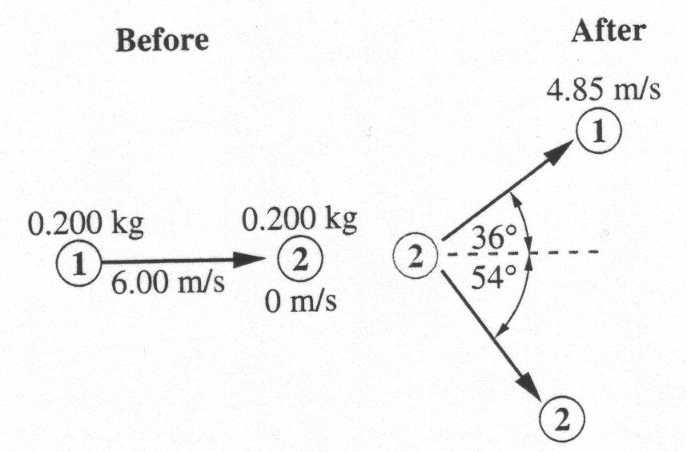

1. The magnitude of the **momentum** of puck 2 after the collision was

A. 1.33 kg·m/s

B. 0.970 kg·m/s

C. 0.705 kg·m/s

D. 0.570 kg·m/s

1. Which of the following units are correct units for momentum?

A. J·s

B. N·m

C. N·s

D. N/J

**Answers**

Multiple choice Numerical Response

|  |  |
| --- | --- |
| 1. D 2. C 3. A 4. A 5. C 6. A 7. C 8. C | 1. 9.09 2. 27.9 3. 2.79 |